COS 214 Practical 3
Code Masters
Team Members:
Kyle Pillay
Takunda Mugwagwa
Brett Pitts

1.1 PixelCon is a one-day gaming convention held across a single indoor/outdoor venue. Attendees move between gaming halls, a competitive tournament zone, and an outdoor plaza containing food, merchandise, and ticketing. The event runs on a live coordination system: a central control point can issue notices, schedule changes, capacity warnings, weather alerts, and evacuation instructions, that must reach the correct operational units without any single class needing to know about every other class in the venue.
The venue is large enough to justify genuine, nested structure. The root event contains multiple halls; one hall contains a further nested zone dedicated to tournament play; and every hall contains several individually reactive operational units. This gives PixelCon three levels of Composite nesting below the root, and units that behave meaningfully differently from one another even though they all respond to the same shared interface.
Groupings / areas
- PC Hall — houses PC gaming stations and VR demo booths, plus a nested sub-zone.
- Tournament Zone — nested inside PC Hall; hosts the competitive bracket play for the event.
- Console Hall — houses console and handheld gaming stations, plus an information desk.
- Outdoor Plaza — houses mobile gaming, food, merchandise, and ticketing — the only area directly exposed to weather.
Concrete event units
- PC Station — a desktop gaming seat. Indoor unit; ignores weather alerts entirely, but shuts down immediately on evacuation.
- Console Station — a console gaming seat. On close, finishes and saves any active session rather than dropping it instantly.
- Switch Station — a portable handheld station. Runs in a reduced-capacity "portable mode" and otherwise ignores most notices except evacuation.
- VR Booth — a VR demo pod. Enforces a cooldown period before it can reopen after closing, and pauses new sessions (without cutting off an in-progress one) during a capacity alert.
- Tournament Desk — manages bracket registration and round scheduling, reacts to schedule-change notices by delaying the active round.
- Info Desk — never fully closes, only reduces staffing; updates its announcement board in response to every notice type it receives, unlike most units which only react to specific ones.
- Merch Vendor — reinterprets "capacity" as remaining stock rather than headcount, and flags itself for restock during a capacity alert.
- Food Vendor — the one indoor-vs-outdoor-sensitive vendor: actually closes on a weather alert,and finishes a mid-order before shutting down.
- Mobile Station — a lightweight mobile-gaming station with near-instant open/close and a queue that reshuffles on schedule changes.
- Ticket Booth — the only unit that stays locked shut after an evacuation until an explicit resume notice arrives, rather than reopening freely.

1.2
Main plays the clients for all.
Composite pattern participants
- Component = EventComponent
- Composite = EventGroup
- Leaf = EventUnit and its ten concrete descendants: PCStation, ConsoleStation, SwitchStation, MobileStation, VRBooth, TournamentDesk, InfoDesk, MerchVendor, FoodVendor, TicketBooth
- Client = main.cpp
Observer pattern participants
- Subject = Subject (abstract)
- ConcreteSubject = EventGroup, EventControl
- Observer = Observer (abstract)
- ConcreteObserver = EventGroup, and the ten concrete EventUnit descendants listed above

EventGroup participates in three roles:
- As Composite, it owns and recurses over its children.
- As ConcreteSubject, it can have observers attached to it (typically, but not necessarily, its own children) and pushes notices to them.
- As ConcreteObserver, it can itself be registered with a parent EventGroup (or with EventControl), so a notice issued above it is received via update() and then re-broadcast downward via its own notify(). This is what makes a notice cascade through multiple tree levels.
EventUnit (and every concrete leaf),participates in two roles:
- As Leaf, it is a terminal node in the Composite.
- As ConcreteObserver, it can be attach()ed to whichever EventGroup contains it and reacts to notices via update().

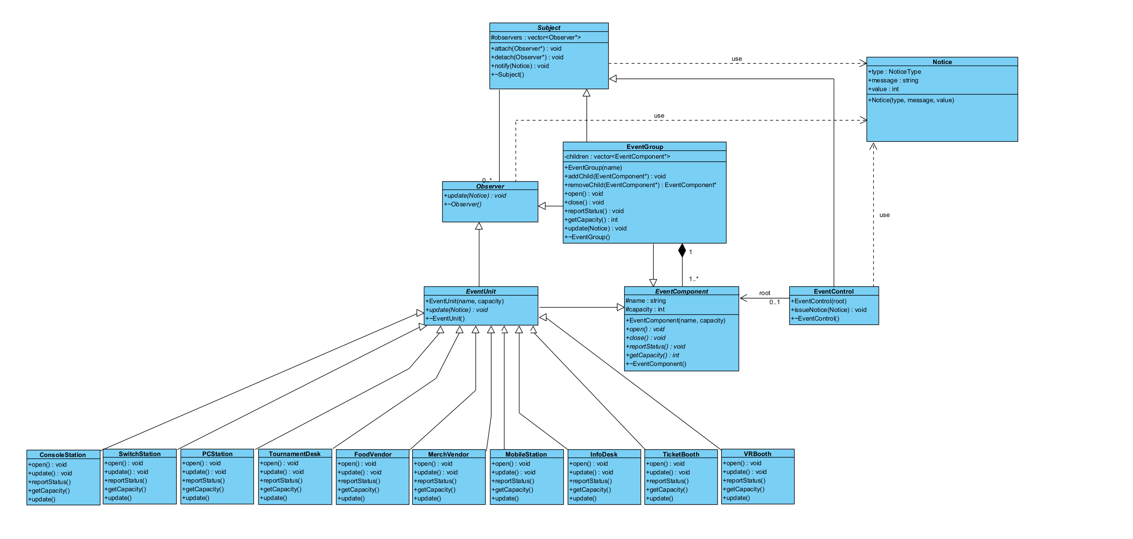
1.3

1.4
a) Composite as a genuine part-whole tree. EventGroup doesn't just reference its children, it owns them: each child is added via addChildren(), belongs to exactly one group, and is deleted when that group's destructor runs. Since a child can itself be an EventGroup, deletion recurses, delete pixelCon releases the entire subtree. That ownership contract is what makes it a tree, not a plain list.
(b) Why Observer is required. Without it, EventControl would need to hard-code a call to every concrete unit for every notice, rewritten each time a unit moves or changes. attach/detach/notify let a subject broadcast to whoever is currently registered without knowing their concrete type.
(c) Who owns event components. EventGroup owns its children exclusively, addChildren() takes ownership, ~EventGroup() deletes each child once, and removeChildren() hands ownership back without deleting, so a unit can be safely re-parented. The root is owned by whoever creates it in main.cpp.
(d) Who owns observer references. Subject never owns its observers, observers is a vector of raw, non-owning pointers, and ~Subject() just clears the list. lifetime is decided by the Composite tree, registration is a freely changeable relationship. If Subject owned observers too, moving a unit between groups would risk a double-free.
(e) Why EventGroup being Subject and Observer isn't a misuse. Ownership lives in children; notification lives in observers; being notified is a third link entirely, tracked by nothing more than being attached somewhere. addChildren() never auto-attach()s, so a child can be structurally contained without listening for notices, proving the two collaborations stay genuinely separate even when the same object plays both roles.
2.3


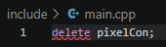
2.4

pixelCon is the root EventGroup, containing PC Hall, Console Hall, and Outdoor Plaza, each of which contains their own leaves. This one call is sufficient to release the entire multi-level tree.
Why it's released exactly once: EventGroup's destructor loops over its children and calls delete on each. Since children are stored as EventComponent*, the virtual destructor ensures the correct derived destructor runs,and if a child is itself an EventGroup, its destructor runs the same loop, so deletion recurses naturally down every level.
Transfer rule: removeChildren() erases the pointer (and detach()es it if registered) but never deletes, ownership passes back to the caller, not to the void. The object can then be safely addChildren()'d onto a new parent. At no point do two children lists hold the same pointer, which is what prevents double deletion during a transfer.
3.4 Output will be:
[PixelCon] received notice: Round times shifted by 30 minutes
[PC Hall] received notice: Round times shifted by 30 minutes
[Tournament Zone] received notice: Round times shifted by 30 minutes
Main Bracket Desk delaying round 1
What happens:
Four levels react in sequence from one issueNotice() call, EventControl → PixelCon → PC Hall → Tournament Zone → TournamentDesk.
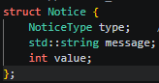
3.5 We use push as notify() passes a full Notice straight into update(const Notice&) observers never call back for more data.

Trade-off. no stored current state, no back-reference needed from observer to subject and we don’t have to call many functions to figure out what the notice is about. The cost is rigidity ,every notice type has to fit the same Notice shape, even for leaves. Pull would scale better if observers needed very different data but would require each observer to know its subject's interface. For EventFlow's small, uniform notices, Push is the simpler fit.





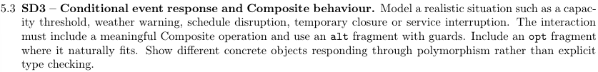


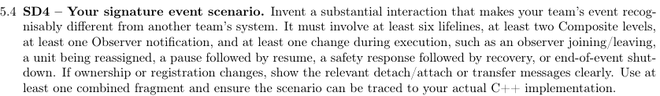


Here

Yash completed:
1.
2.
3.
Takunda completed:
1.
2.
3.
Brett completed:
1.
2.
3.

Evidence:


